Introduction

Description of Theme and Topic Rationale
Backend architecture refers to how a server-side system is organised into components, responsibilities, and dependency boundaries [1]. A common architectural choice in backend development is whether to build a monolithic system, in which most functionality is implemented within one tightly connected codebase, or a modular or layered system, in which responsibilities are separated into clearer units such as routing, services, and data access [1]. This choice is important because architecture affects how easily a system can be changed, tested, and maintained over time. Research on architectural smells and technical debt shows that unclear boundaries and poor structure can increase long-term effort and reduce maintainability, supporting the need for evidence-based evaluation of architectural decisions [1]-[3].
This study focuses on a dataset-driven case-tracking application in order to compare these approaches in a controlled manner [5]. Two backends are built with the same user-facing behaviour, including importing a synthetic JSON dataset into PostgreSQL, validating and normalising records, logging import runs, and exposing search and trend functionality [5]. Comparing two implementations with identical requirements is appropriate because it allows differences in maintainability, testability, and operational performance to be measured under consistent conditions rather than assumed [3], [12].

Positioning and Research Onion
This study adopts a pragmatist philosophy because it aims to develop and evaluate a working software artefact and to draw conclusions from practical, measurable evidence. This position is appropriate because the outcome is assessed using objective metrics collected from the implemented systems rather than the researcher’s personal opinion. The study follows a deductive approach, as it seeks to test the predefined hypothesis that a modular or layered architecture provides better maintainability and testability than a monolithic design.

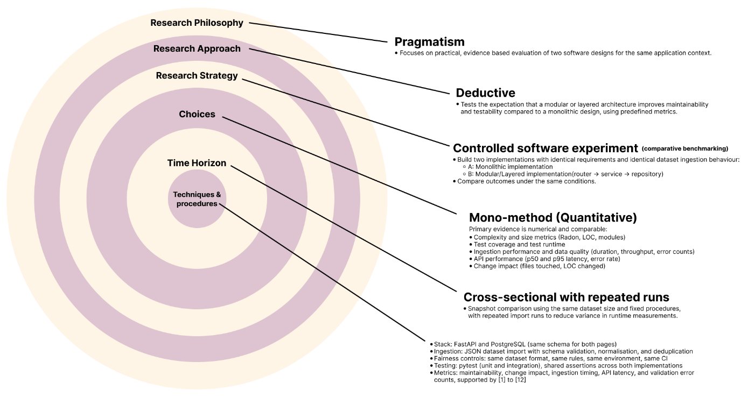Fig 1. Research Onion for the Study

The research strategy is a controlled software experiment based on comparative benchmarking. Two backend implementations are developed with identical requirements, identical dataset ingestion behaviour, and the same API contract. The analysis uses a mono-method quantitative strategy, since the research questions are addressed through numerical measures that can be compared across both architectures, including structural metrics, testing results, and performance timings. The time horizon is cross-sectional with repeated runs, meaning that both systems are evaluated at the same stage of completion while measurements are repeated to reduce random variation in runtime results. Recent research also shows growing interest in modular monolith designs and modular boundary practices, while emphasising the need for clearer evaluation evidence across different contexts [9], [10].

Background to this Research Theme
Architectural quality is closely related to maintainability, and architectural smells are recurring patterns that often indicate deeper design problems. Systematic evidence shows increasing interest in detecting and managing such smells as part of maintaining long-term system quality [1], while technical debt research also suggests that weak boundaries and widespread dependencies can create future cost [2]. Empirical studies further link the presence of smells to maintainability outcomes, indicating that architecture can affect measurable software quality rather than simply reflecting design preference [3].

Hypothesis, Research Aim, and Purpose Statement
This study will test the hypothesis that a modular or layered architecture is more maintainable and testable than a monolithic architecture.
The purpose of this controlled comparative experiment will be to test the theory that architectural modularity improves software quality by relating backend architecture type to maintainability and testability outcomes, while controlling for identical requirements, dataset, database schema, API contract, test suite, and runtime environment across both implementations. The independent variable will be backend architecture type, defined as a monolithic backend or a modular or layered backend. The dependent variables will be maintainability and testability, defined using tool-based structural measures and automated test evidence.

